1. **Correlation in Attrition vs. Gender**

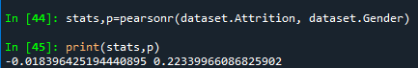

Conclusion: There is barely any correlation with respect to gender and attrition, all types employees, Male or Female did left the company.

1. **Correlation in Attrition vs. Monthly Salary**

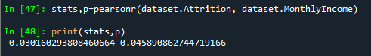

Conclusion: There is barely any correlation with respect to gender and attrition, all types employees, with different salaries .

1. **Correlation in Attrition vs. Age**

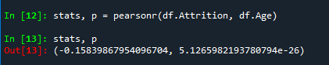

Conclusion: P value does not exceed 0.05 (alpha) H0 is accepted

1. **Correlation in Attrition vs. Education**

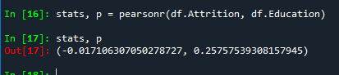

Conclusion: Again all employees with different Education background left the company

1. **Correlation in Attrition vs. Distance from home**



1. **Correlation in Attrition vs. YearsWithCurrManager**



1. **Correlation in Attrition vs. YearsSinceLastPromotion**

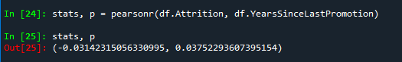

1. **Correlation in Attrition vs. YearsAtCompany**

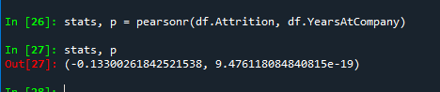

1. **Correlation in Attrition vs. PercentSalaryHike**

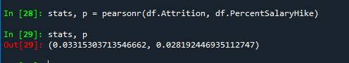

1. **Correlation in Attrition vs. TotalWorkingYears**

